|  |  |
| --- | --- |
| **Online Book Store** |  |

**Today a reader, tomorrow a leader.**

**T**he primary goal of any e-commerce site is to sell goods, services and profiting, but that's not our goal. We do not sell books but spread knowledge, passion and encourage people to open books rather than opening smart devices. We aim to spread the love of reading to all people, because we do believe that the right book in the right hands at the right time can change the world.

**T**he benefit of our online bookstore is that it saves your time, you have a wide collection of various genres of books so you can choose books according to your interests in no time while relaxing at home, also it’s a major consideration for those who live in areas where the access of bookstores is limited.

**T**he user creates an account in our website by signing up, then he can navigate through the website, add books to his cart, read or add a book review, evaluate books or anything he likes, he can review the books added to his cart by clicking on (My Cart).

**T**he following image is an initial version of the interface of our website, it contains a sign in section if the user already has an account, if not he can press on the link (Don’t have an account?) to direct him in the sign up page, there is a navigation bar and a social media section to keep up with our customers, and other features.

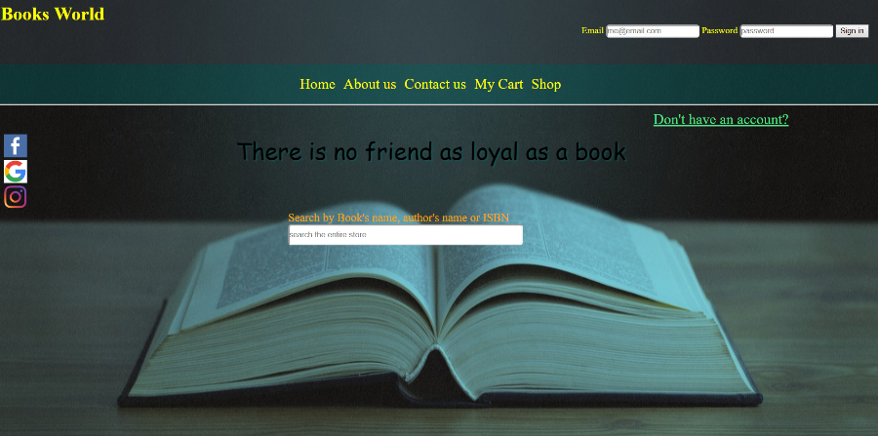

**O**ur website has a unique feature which is exchanging books! When the user sign in then open the books’ category he choose a book from the exchangeable section then in return he uploads a photo and the condition of the book he wants to exchange with.

**O**ur mission is to facilitate the process of buying books and exchanging books anywhere at any time as the online process helped a lot on this, we also aim to create a reading community through the reviews and the feedbacks of our customers and the interaction of our customers together through our website, we also aim to attract the user by our various books’ sections including new releases, bestselling books and our various genres of books